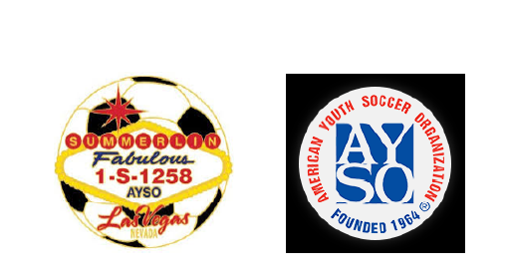
AYSO Region 1258 Board Meeting Minutes
Date: Sunday, February 15th, 2026
Time: 6:30 PM
Location: Virtual via Zoom
Attendees will be checked:
Kim Wilkinson | Denise Kubajak | Jill Contreras
Mindy Veytia | Tim Downing | Andrew Contreras
Mike Bauder | Andrew Musgrove | Kennedy Sanchez
Mike Schramm | Max Corrick

Topic 1: Denise: Registration Numbers-

^{Division} | ^{Boys} | ^{Girls} | ^{Coed} | ^{Waitlist} | ^{Teams}
^{6U} | ⁴⁸ | ⁴⁸ | ~~~~~~~~~~ | ^{Boys: 2}  ^{Girls: 2} | ^{Boys: 8}  ^{Girls: 8}
^{8U} | ⁶² | ⁵² | ~~~~~~~~~~ | ^{Boys: 0}  ^{Girls: 0} | ^{Boys: 8}  ^{Girls: 8}
^{10U} | ⁷⁰ | ⁷⁰ | ~~~~~~~~~~ | ^{Boys: 6}  ^{Girls: 1} | ^{Boys: 7}  ^{Girls: 7}
^{12U} | ⁷¹ | ³⁶ | ~~~~~~~~~~~ | ^{Boys: 1}  ^{Girls: 7} | ^{Boys: 6}  ^{Girls: 3}
^{14U} | ⁵⁵ | ⁴² | ~~~~~~~~~~ | ^{Boys: 0}  ^{Girls: 1} | ^{Boys: 4}  ^{Girls: 3}
^{18U} | ~~~~~~~~~~~~~~~~ | ~~~~~~~~~~~~~~ | ⁴⁸ | ⁴ | ⁴
 |  |  | ^{TOTAL: 602}

Topic 2: 6U coaches:
- Need 3, 6U boys head coaches
- Need 1, 6U girls head coach
Topic 3: Allstars:
- Downing’s team still in
Topic 4: Referee:
- Training dates coming soon
Topic 5: Coach equipment distribution on Tuesday 2/17 (if weather permits) and Saturday 2/21.
Topic 6: Rodeo Show to take place during first weekend of June
Topic 7: AYSO “Lights Night” on 4th of July
Topic 8: May get trophy cups instead of participation medals this season.
Topic 9: Connex Box Schedule:
Day: | Open: | Close:
Monday | ?? | Andrew/Jill
Tuesday | Denise | Kim/Mindy
Wednesday | ?? | Andrew/Jill
Thursday | Denise | Mindy

Topic 10: Next Board meeting Sunday Feb 22nd, 2026 @ 6:30pm via Zoom

